**QUE-24.4.1- Write a hive query find the average age of male and female persons died in the titanic tragedy**

***TABLE CREATION-***

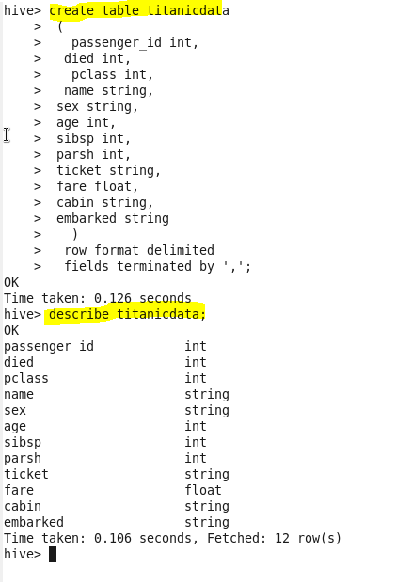

***LOADING THE DATA-***



***OUTPUT-***

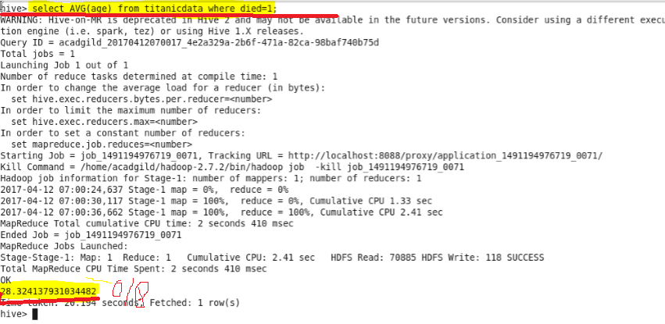

**QUE-24.4.2- Write a hive query to find the number of people died and survived in each class**

***OUTPUT-***

